Name:______________________________________ Date:____________________

SPH3U Electricity Investigation – Series Circuits & Parallel Circuits

Part I – Series Circuits

Problem:

What are the electric potential and electric current relationships in series circuits?

Materials:

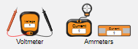
PhET DC Circuit Lab – HTML5 version

https://phet.colorado.edu/sims/html/circuit-construction-kit-dc/

Procedure:

- Set up the series circuit shown in the diagram. Points have been labelled for reference only and represent junction points in the circuit. [1]
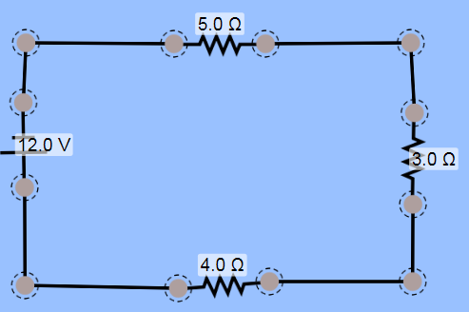

a
b
c
d
e
f
g
h

- Connect the positive terminal of the of the voltmeter to point h, and then touch the labelled points in turn, noting and recording the reading on the voltmeter in each case. Calculate, by subtraction (V_{b} – V_{a} = V_{ab}), the potential difference across the power source and across each load and conductor. Remove the voltmeter from the circuit.

- Use the ammeter to measure the current through each conductor in the circuit. Record your results in Table 1.

Table 1 – Series Circuits [4]

Junction Point | Electric Potential (V) | Conductor | Potential Difference (V) | Electric Current (A)
a |  | ab
b |  | bc
c |  | cd
d |  | de
e |  | ef
f |  | fg
g

Questions: (Answer in complete sentences.)

- How many paths are there for an electron to take through the series circuit? [1]

- Calculate the sum of the decreases of the electric potential along the path, and the sum of the electric potential increases. State the relationship between the two. [4]

- In a series circuit how does the total current from the power source compare with the current through each individual resistor? [1]

Part II – Parallel Circuits

Problem:

What are the electric potential and electric current relationships in parallel circuits?

Materials:
PhET DC Circuit Lab – HTML5 version

https://phet.colorado.edu/sims/html/circuit-construction-kit-dc/

Procedure:

- Set up the parallel circuit shown in the diagram, using the same notation for junction points [1]

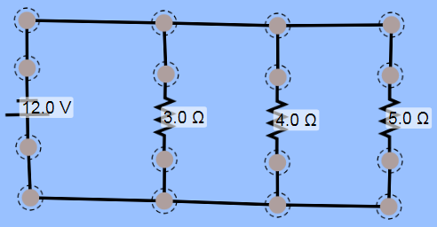
b
c
d

a

h

g
e
f

- In the same way as before, connect the positive terminal of a voltmeter to point h and then take readings of electric potential at each point. Then calculate by subtraction (V_{b} - V_{a} = V_{ab}) the potential difference across the source and across each load and conductor.

- Use the ammeter to measure the current through each conductor in the circuit. Record your results in Table 2.

Table 2 – Parallel Circuits [4]

Junction Point | Electric Potential (V) | Conductor | Potential Difference (V) | Electric Current (A)
a |  | ab
b |  | bc
c |  | cd
d |  | de
e |  | ef
f |  | fg
g

Questions: (Answer in complete sentences)

- How many different path are there for an electron to take through this parallel circuit? [1]

- Calculate the sum of the electric currents in the three branches of the circuit, and compare with the current leaving the source. State the relationship between the two. [4]

- In a parallel circuit, how does the potential difference across the load compare with the potential difference across the power source? [1]

