Student guide: Name:____________________
Start:
Phet Energy Skate Park basics
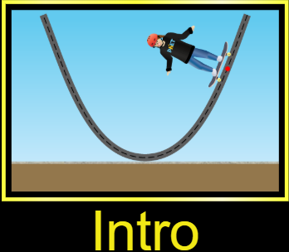
- Click on the first link
- Click on the  button.
- Select “Intro” from the three options.
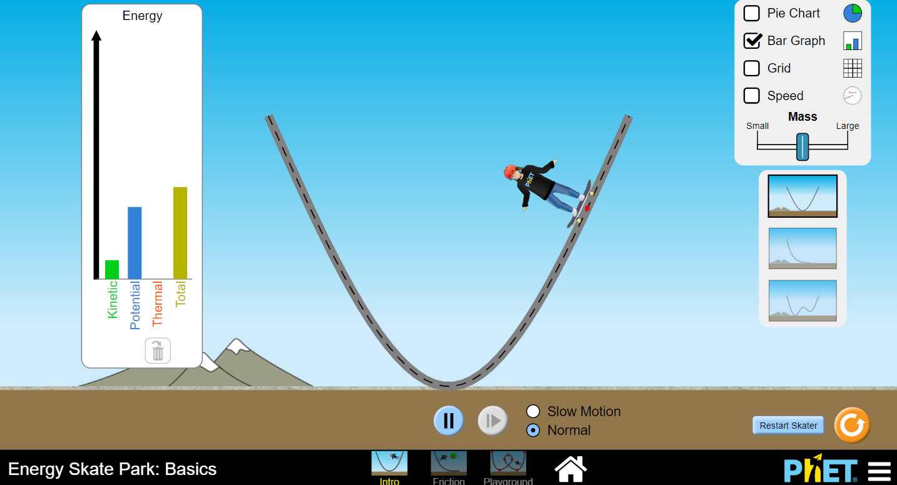
 Time to explore potential energy, kinetic energy and conservation of energy.
- Then make your screen look like the picture by
- clicking the box next to bar graph
- clicking the box next to pie chart
- Dragging the skater to the top of the ramp
- Releasing the skater.
  -  Discuss the changes in the bar graph as the skater moves on the track
  - Use the symbols to fill in the data table:
(↑ increases, ↓ decreases, S for stays the same)
Skater’s movement |  | Potential energy  ( ↑ ↓ S ) | Kinetic energy  ( ↓ ↑ S ) | Total energy  ( ↑ ↓ S )
Down the hill | 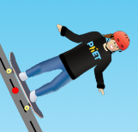
Up the hill | 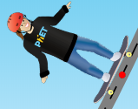
 Discuss any patterns you see for the energy data table.

- What happens if you drop the skater onto the track from above the track? Why?

- Add symbols ( ↓ ↑ S ) to complete the observation statements:
As an object moves down the track, the kinetic energy _________ and the potential energy ____________. When the object moves up the track the kinetic energy ________ and the potential energy _______.
- Look at your data table and focus on the Total energy column. Write a complete sentence about the “total energy” of the object moving up and down the track.

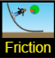
Time to explore friction!
- At the bottom, click “Friction”
  - Click the box next to bar graph
  - Click the box next to pie chart
  - Move the slider to change the friction
Discuss the changes in the bar graph as the skater moves up and down on the track.
- Use the symbols to fill in the data table.
(↑ increases, ↓ decreases, S stays the same)
Skater’s movement | Potential energy  ( ↑ ↓ S ) | Kinetic energy  ( ↓ ↑ S ) | Total energy  ( ↑ ↓ S ) | ________  ( ↑ ↓ S )
Down hill
Up the hill
Discuss any patterns you see in the data table.
Add arrows the complete the following observations. ( ↑ ↓ S )
- As an object moves down the track, the kinetic energy _________ and the potential energy ____________. The total energy __________________.

- After watching the bar graph while the object is moving, especially with “lots” of friction, write a title for the last column. Use the symbols to fill in the last column.
- -complete the observation statement:
As the skater moves with friction, the kinetic energy and potential energy both ___, the thermal energy________ and the total energy ________.
Write a possible explanation for this. ______________________________________________
______________________________________________________________________________________
- Discuss what changed and what stayed the same when friction added to the skate park .
____________________________________________________________________
____________________________________________________________________
____________________________________________________________________
- Which situation, with friction or without friction, is more similar to your everyday experience on a skateboard or bicycle? Write at least 2 sentences to explain your answer.

____________________________________________________________________
____________________________________________________________________
____________________________________________________________________

Finally, click “Playground” at the bottom: 
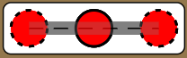
Create a track with at least one loop. Drag segments to make loops.
Draw a diagram of your track here.

Slide friction to “None”.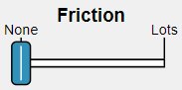
Release your skater from below the top of the loop. Write a complete sentence explaining what happens.
________________________________________________________________________________________________________________________________________

Release your skater from above the loop. Explain what happens, using the words Kinetic Energy, Potential Energy, AND Total energy!
____________________________________________________________________
____________________________________________________________________

Now slide “Friction” to the right a little bit. What happens to the skater?
____________________________________________________________________________________________________________________________________________________________________________________________________________

Based on what you just learned, how must roller coasters be designed so that they will go through loops successfully? Use the words Potential Energy, Total Energy, and Friction!
____________________________________________________________________________________________________________________________________________________________________________________________________________

