Title: Eating and Exercise

Introductions
In this activity you will investigate the physical science of eating and exercising and the relationship between calories consumed with calories burned.

Definition:
Calories are a unit of energy that is used to measure the amount of energy stored in food

Objective:
Create a rule that describes a balanced lifestyle using a combination of diet and exercise.

Important Questions:
What is the relationship between the energy we intake and the energy we burn?
What is needed to maintain a healthy BMI?
What are some long term effects of diet and exercise?

Instructions:
Human bodies have the incredible ability to intake and burn calories. The balance of eating food and participating in physical activities can influence factors such as weight and heart rate. In this activity we will use a simulation to examine realistic lifestyle choices and how diet and exercise effect our bodies over long periods of time.

1. Click this link: http://phet.colorado.edu/
This is a screen shot of the website:

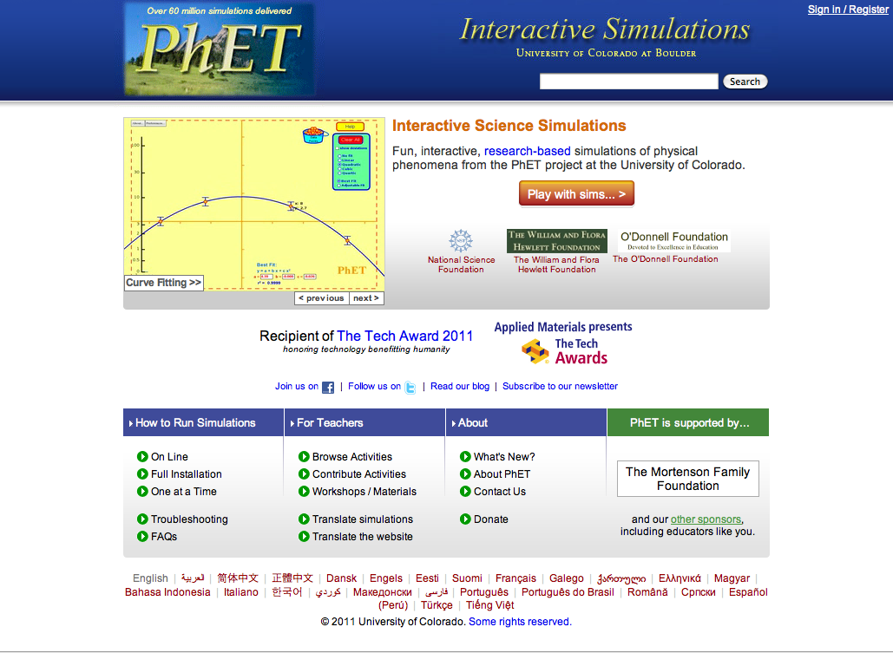

2. Click the “Play with sims” button.
3. Click “New Sims” -> Click “Eating and Exercise”->Click “Run Now!”
4. It will take time to load and then this screen appears:
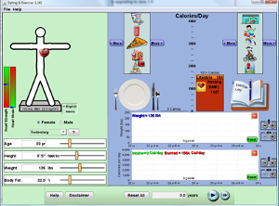

Switch between this document and the sim to complete the activity.

Explore

- Fill out information for your age, height, weight, and daily activity.

- Place various foods that you would typically eat in a day on the plate, include breakfast, lunch, and dinner.

- Take note of your daily calorie intake (proteins, carbs, fats).

- Select different forms of exercise and take note of how many calories are burned during different activities.

- Set the time for 1 year and play the simulation to see how your typical calorie intake and daily exercise affects your weight as time passes.

Questions

- What is a BMI? What BMI is considered “starving”? What BMI is considered “obese”? What else do you observe on the simulation?

- How many total calories do you intake in a typical day?

- How many total calories are burned in a typical day?

- Based on your responses to the previous questions, how will your body be affected over the course of one year? Consider weight, heart strength, and heart strain.

Explain
What is a BMI? What BMI is considered “starving”? What BMI is considered “obese”? What else do you observe on the simulation?

Using the simulation set the person parameter settings for a 25 yr old female that is 5’4, 145lbs, and 25.8% body fat.

Lifestyle | Lifestyle Cal/day burned
Very Sedentary
Sedentary
Moderate Activity
Very Active
*Lifestyle cal/day burned is found in orange

Now set the person parameter settings for a 25 yr old male that is 6’0”, 195lbs, and 20% body fat.

Lifestyle | Lifestyle Cal/day burned
Very Sedentary
Sedentary
Moderate Activity
Very Active
*Lifestyle cal/day burned is found in orange

Which lifestyle type requires the most calories per day for both male and female when no exercise is being performed? Why do you think this is so?

What types of energy are involved in the sim? What body systems are associated with the different types of energy?

Come up with a rule for a balanced lifestyle using a combination of diet and exercise/lifestyle.

Apply

Set the person parameters to any realistic setting of your choosing for a female:
Lifestyle:
Height:
Weight:

*The % body fat will adjust automatically for you.
*Set the time to show 1yr.

Use the simulation to complete the chart below.

Cal. Intake/ day | Cal. burned/ day | Gain/Loss/Maintain
1500
 | 350
 |  | Maintain
*Remember that 3500 calories = 1.0lb of fat
*Click on the more tabs to see more options of food and exercise activity

Set the person parameters to any realistic setting of your choosing for a male:
Lifestyle:
Height:
Weight:

*The % body fat will adjust automatically for you.
*Set the time to show 1yr.

Use the simulation to complete the chart below.

Cal. Intake/ day | Cal. burned/ day | Gain/Loss/Maintain
1900
 |  | Maintain
 | 500
*Remember that 3500 calories = 1.0lb of fat
*Click on the more tabs to see more options of food and exercise activity

How do the two graphs relate to each other?
What did you have to do to make their body fat stay stable?

Conclusion: Compare the data and explain how it supports your rule.

