Title: Friction

Definition:

Friction is defined as the resistance that one surface or object encounters when moving over another. It is a force that opposes motion, or makes it hard for an object to move across a surface.

Important Questions:

What does the amount of friction on an object depend on?
How do we measure the amount of friction between two objects?
How does friction help and hinder things we do in everyday life?

Instructions:

In this activity, the above questions are investigated. Complete this document by filling in data tables and writing complete responses. This investigation has three phases: Exploration, Explanation and Application. Work between this document and the simulation (sim).

1. Click this link: Friction Simulation
4. This screen appears.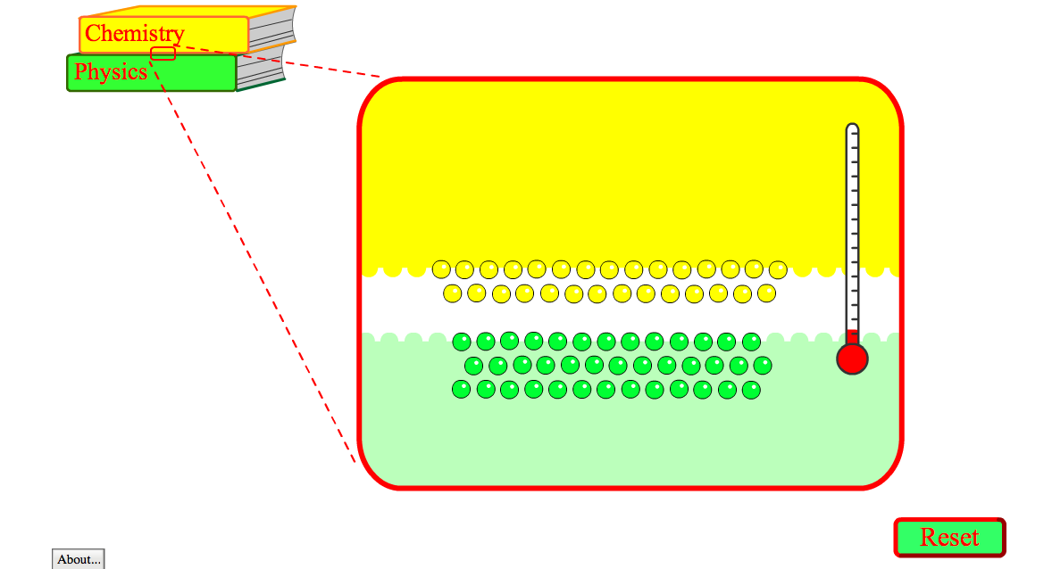

Exploration Phase:

1. Briefly explore this sim. Start by only moving the yellow textbook left to right and right to left.
2. Observe how the particles are initially moving (fast, slow, direction) and the starting temperature on the thermometer to the right. Now, put your cursor on the yellow textbook and pull it down so that the particles begin to come together.

3. Explore what happens as you rub the two textbooks together, can you change the results based on how fast or how slow they are rubbed together?

4. What happens to the temperature as the textbooks are rubbed together?

5. Notice the reset button in the bottom right hand corner.

Questions

- How do you make the temperature increase?

- How do you make the temperature decrease?

- How do you make the particles move faster?

Explanation Phase:

This Phase has an investigative goal.

Aim: How does friction affect the motion of objects?

Click this link: Forces and Motion and hit the big play button. Click on the “Friction” tab. Make sure that “Forces”, “Sum of Forces”, “Values”, and “Masses” are checked. This is what the screen should look like:

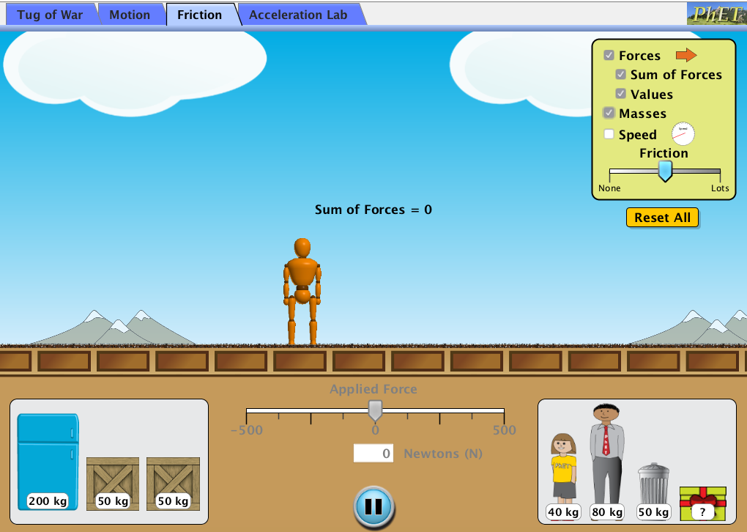

Use these concepts:

An applied force causes an object to be set in motion.
A friction force causes an object to slow down and/or stop.

Below are six different combinations for creating friction and motion. Test each condition with the sim and fill in the blanks.

 | Object’s Mass  (kg) | Friction Force  (N) | Applied Force  (N) | Sum of Forces (larger force – smaller force)
1 | 40 |  | 500
2 |  | 200 |  | 300
3 | 100 | 250
4 | 100 |  | 246
5 |  | 300 | 500
6 | 200 |  | 500

How does friction affect the motion of objects?

What happens when you get a sum of forces that is equal to 0?

Set the friction to “none”. What does the material of the surface look like?

Complete the table below with no friction.

1 | 100 |  | 248 | 248
2 | 200 |  |  | 124
3 | 280 |  | 40

What is the value of the friction force (N) for each new condition?

What about the surface do you think causes the resulting friction force values?

Application Phase:

How can you determine the weight of the mystery object?

Experiment and find the values to complete the table (using lots of friction) in order to find out the weight of the mystery object.

 | Object’s Mass  (kg) | Friction Force  (N) | Applied Force  (N) | Sum of Forces (larger force – smaller force)
1 | 40 | 200 |  | 49
? |  | 250 | 376 | 126

How would your results change if there were no friction?

Does the temperature of a surface affect the amount of friction created?

If you wanted to move a heavy object across a surface what conditions would be most ideal in order to be able to move it quickly?

Finished: Congratulations.

