What is in a Chemical Formula? Name:____________________
Enrichment/extension/homework
Molecular formula | Name of compound | types of atoms | Number of atoms
C₆H₁₂O₆ | Glucose | __________  __________  __________ | __________  __________  __________
O₃ | Ozone | __________  __________  __________ | __________  __________  __________
2H₂0 | water | __________  __________  __________ | __________  __________  __________
3NaCl | Sodium chloride (table salt) | __________  __________  __________ | __________  __________  __________
C₈H₁₈ | octane | __________  __________  __________ | __________  __________  __________
C₆H₈O₇ | Citric acid | __________  __________  __________ | __________  __________  __________
C₈H₁₀N₄O₂ | caffeine | __________  __________  __________  __________  __________ | __________  __________  __________  __________  __________
The following is a structural formula: 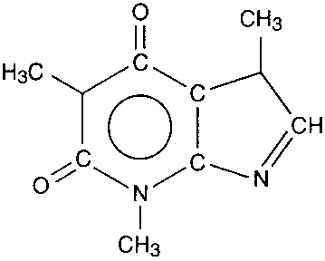
What is the name of this molecule?
_____________

