Guiding Question: What makes a molecule different from an atom?
Learning Goals: Students will be able to:
- Identify the types of atoms and the number(s) of each atom making up a molecule
- Distinguish between multiple molecules (coefficients) and multiple atoms (subscripts) in a chemical formula

- Build molecules, given chemical formulas, using various “kits” of atoms
- Experiment with combining atoms to build larger molecules.
Background:
Students working on this lesson have completed the study of the atom and atomic theory. They have completed the Build an Atom and have an understanding of atomic number, atomic mass and the trends of the periodic table. This activity is an introduction to the combined nature of matter (molecules), and a helpful activity to prepare students for balancing chemical equations and very basic types of chemical reactions.
 indicates students write a response 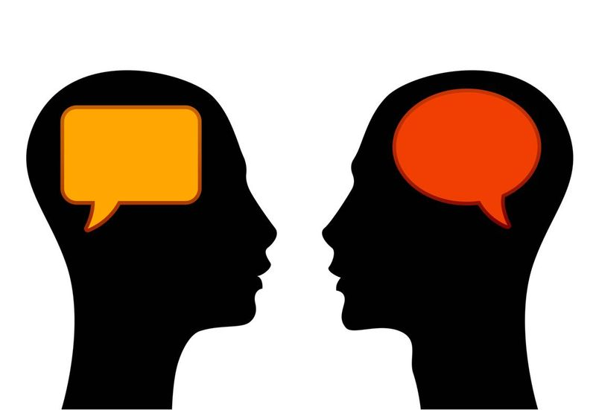 indicates students discuss with partner

Indicates students should check in with teacher before going further

Teacher notes:
- Let the groups (two or three students) explore - It is useful for students to discover the “kits” and “collections” on their own before starting the activity. It will make the instructions in the student guide easier to follow.
- This activity has many opportunities for sharing-out information as the students discover that molecules are made up of atoms. It is useful to start the following class with the simulation projected on the board and invite students to share what they learned.
- This activity can be done as homework if time is limited. Going over the work, and the sharing of discoveries, is very important in this case because there will be a few students who don’t complete the assignment and they can still be able to learn some of the material through the in-class sharing.
- This activity is a good segue to teaching about chemical reactions and balancing chemical equations using the Balancing Chemical Equations simulation.
- I have included two documents that are useful for group discussion or quizzes. I use these for discussion either as a power point or with clickers optional pre-test , post-test

