Physics Web Search: Forces Name_________________________
Period ________________________

Go to: http://phet.colorado.edu/get_phet/simlauncher.php

Part 1: Forces in One Dimension
    - On the right, make sure friction is “off.”
    - Make sure the “File Cabinet” is selected.
    - Make sure initial position is -7.0 m
    - On the left, set the applied force to 400 N.
    - Graph each of the following options: Total (Net) Force, Acceleration, Velocity, and Position.

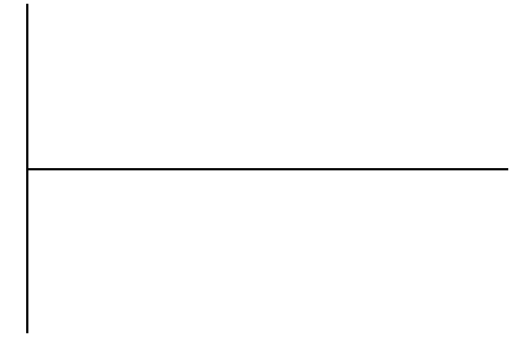
    - Predict how the four graphs will change (or not change) above if you select the refrigerator, but leave the other settings the same.
      - Total Force: _______________________________________________________
      - Acceleration: ______________________________________________________
      - Velocity: __________________________________________________________
      - Position: __________________________________________________________
    - Run the simulation again and redraw the four graphs from above. If your predictions were incorrect, comment below each graph as to why.

    - Switch back to the filing cabinet, and turn friction “on.”
    - Run the simulation again with the Applied Force still set to 400 N.
    - What is the total force? _______ Why? ________________________________________
    - Using gravity as 9.8 m/s², calculate the maximum force of static friction. The coefficients of static friction are listed under “More Controls.” f_{s max}= _______
    - Set the Applied Force equal to this value.
    - What is the Total Force? __________
    - Add 1 N to the applied force you just used and run the simulation.
    - What is the Total Force? __________ Why is it not 1 N? _________________________ ________________________________________________________________________
    - Click the “Textbook.” Calculate the maximum force of static friction (continue to use 9.8 m/s² for gravity), add 1 N to this number, and set the Applied Force equal to this value. Applied Force = ___________
    - Run the simulation.
    - What is the frictional force listed on the graph: _______
    - Use this frictional force to calculate the coefficient of kinetic friction: ____________
    - If you look under more controls it says the coefficient of kinetic friction is .2. This is not technically wrong, any idea why? ____________________________________________ (Wikipedia “Rounding” – go to: Round Half to Even). You can try changing the value to .25 and see what happens, and also .35.
    - Given that the textbook started -7.0 m from the origin, calculate the exact time that the textbook will get to the origin. Show your work, and check the position graph to see if you are close. t = _______.

Part 2: The Ramp
- Note that gravity in this lab is 9.8 m/s²
- Click on the filing cabinet
- Set the ramp angle equal to 20° (make sure to hit enter so it changes)
- Click “Go” at the bottom right, and then click “Pause” before the filing cabinet slides off the ramp.
- Show work to explain where the values 335.18 N, and 276.27 N come from.

- Set the Applied Force equal to 50 N.
- Calculate the net force acting on the filing cabinet. Show your work.

- Run the simulation, and calculate the time it will take the filing cabinet to reach the end of the ramp (remember it moves 10 m). Check the top left corner of the screen and note the time it takes to reach the end of the ramp t = _________. Show your work.

