Name______________________ Group_____
Gravity Lab Computer Name________________________

Procedure: 1. Search “My Solar System” in the browser. This will find a site with this URL:

http://phet.colorado.edu/en/simulation/my-solar-system

Go to that link and click on “Run Now!” Click the “Show Grid” box on the right of the screen. Drag the slider from “Fast” all the way over to “Accurate”. At the bottom, select “3” for the number of bodies. Then fill out the data table to look like this:

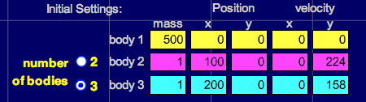

Click on “Start” and observe the motion, then answer the questions below.

Q1: Which planet (inner or outer) travels the least distance to go around once?

Q2: Which planet is going the fastest?

Q3: Which planet has the shortest ”year”?

Q4: About how many times does the inner planet go around while the outer planet goes around once?

Q5: In our solar system, what is the name of the planet that goes the fastest? The slowest?

2. Click “Stop”, then click on the arrow next to “Select Preset” in the upper right of the screen, then scroll down and select “Ellipses”. Click “Start” and answer the following questions about the outer GREEN orbit relative to the yellow “sun”..

Q6: Where in its orbit is the planet going the fastest? Slowest?

Q7: Where do you think gravity is the strongest? Weakest?

Q8: Comets have orbits similar to this one. Where would you expect a comet to spend most of its time, near the Sun or far from the Sun? Why?

3. Click on the “2” by the number of bodies and fill in the data table to look like this:

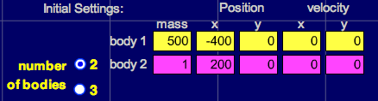

4. Notice the time output in the lower right of the screen. Click on “Start” and watch the small mass fall toward the large mass. Measure the time it takes to hit by clicking on “Stop” as soon as the small mass hits (the large mass will flash when they hit). Repeat the simulation by clicking on “Reset” until you are sure you have an accurate time. Record your time for three trials in the table below.

Q9: Predict what will happen to the time it takes the small planet to fall into the large planet if we double the mass of the small planet. Write your prediction here.

Q10: Change the mass of Body 2 from 1 to 2. Click “Start” and measure the time it takes to hit. Record it in the table below. Was your prediction right?

Q11: Predict the time it will take for body 2 to hit the star if we change its mass from 2 to 3. Write your prediction here.

Q12: Change the mass of Body 2 from 2 to 3. Click “Start” and measure the time it takes to hit. Record it in the table below. Was your prediction right?

Planet Mass | Time  Trial 1 | Time  Trial 2 | Time  Trial 3
1
2
3

Q13: Based on your results, should more massive objects fall to Earth faster than less massive objects? Why or why not?

4. Click “Reset” then de-select the “System Centered” check box on the right of the screen. Fill in the data table to look like this:

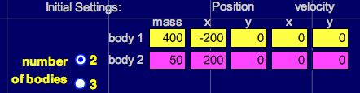

Q14: This creates one big planet and one small planet. Predict which planet will move the most and what will happen after they collide below.

Q15: Click “Reset” then click “Start” and observe. Was your prediction correct? What do they do after they collide?

Q16: Click “Reset” then change the 50 mass planet to 400 so they are equal. Predict what will happen below.

Q17: Now click “Start” and observe. Was your prediction correct? What do they do after they collide?

Q18: Click “Reset” then change the x velocity of planet 1 (yellow) to 100. Predict what will happen after they collide.

Q19: Click “Start” and observe. Was your prediction correct? What do they do after they collide?

5. Go back to the “Presets” menu in the upper right of the screen and select “Four Star Ballet” and run it. Look at a few others if you wish, then make up your own pattern by changing the masses, x and y positions, and x and y velocities. The coolest pattern gets extra credit. If you think you have a good one call the teacher over to judge.

Extra Credit Teacher Signature

