LAB: IDEAL GAS LAWS

Purpose: In this lab you will apply the first law of thermodynamics and Ideal gas laws to analyze behavior of gas in a container.

1. Refer to the parameters of the gas given in the simulation.

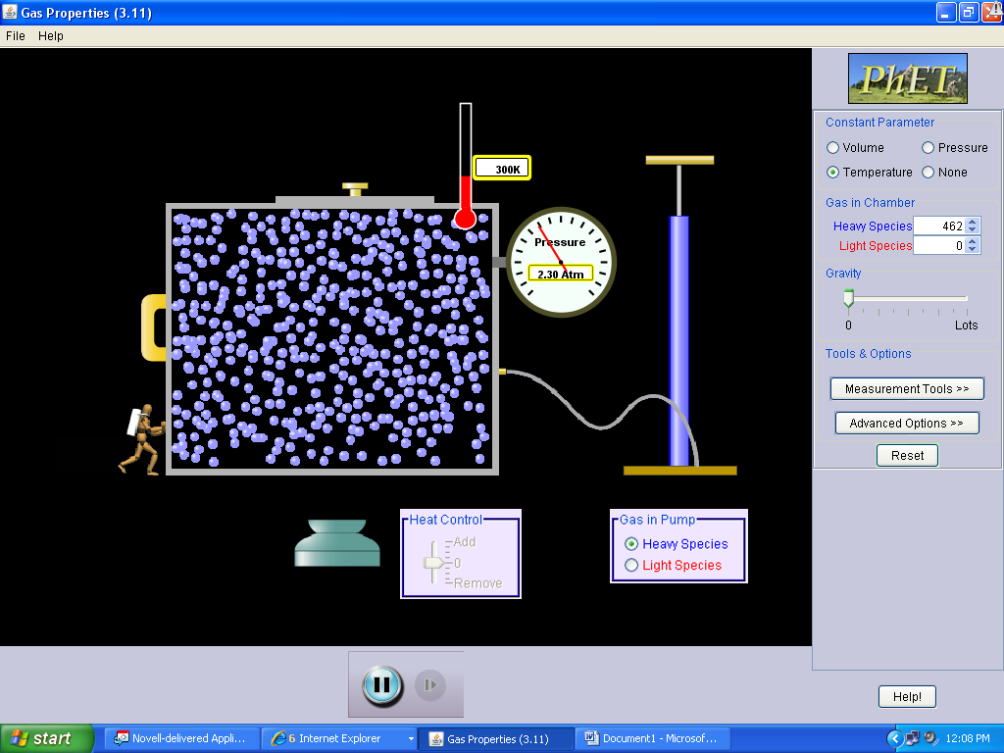 | - Express the amount of gas in terms of moles.  - Determine the internal energy of the gas. Express it in joules.  - The container is of a shape of a cube with the length of side 5.3 nm. What force is exerted by the gas on the top base of the container? Is the force exerted on the bottom of the container the same in magnitude?

- Suppose that a certain amount of heat is added to the gas that resulted in the temperature of the gas change to 838K and the pressure change to 4.5 atm. Use the first law of thermodynamics to find
  - the work done by/on the gas (carefully determine the sign of the work)

  - the final internal energy of the gas

  - the amount of heat added

2. The left side of the container is movable. Suppose that an external force acts on the left side decreasing the volume of the container.
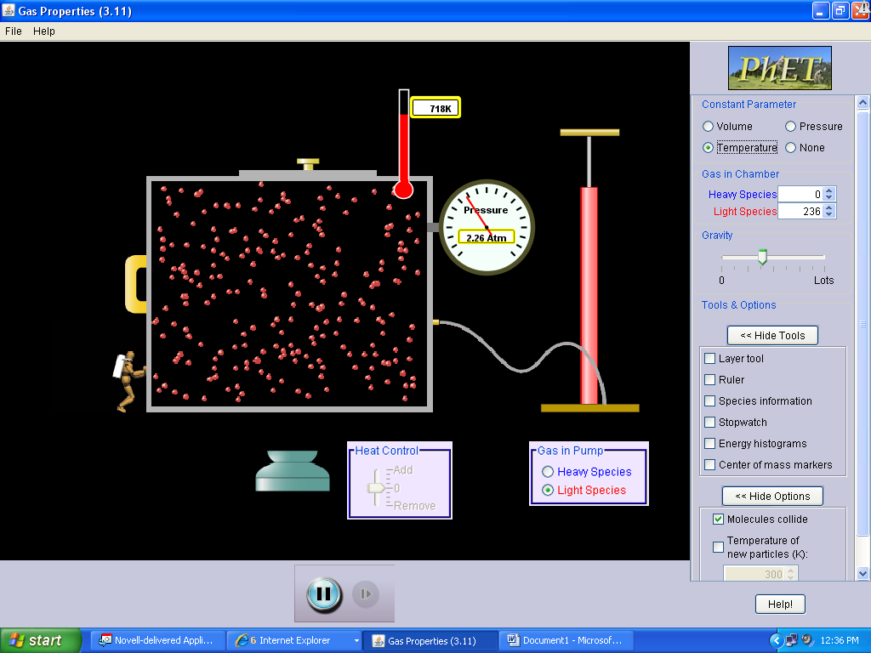 | - If the initial/final temperatures are given in the processes, how would you determine:  - The change of internal energy?  - Heat added or removed?  - Work done on/by the gas?  - Determine the thermodynamics process that took place.

- Suppose that the gas is to expand under constant temperature.

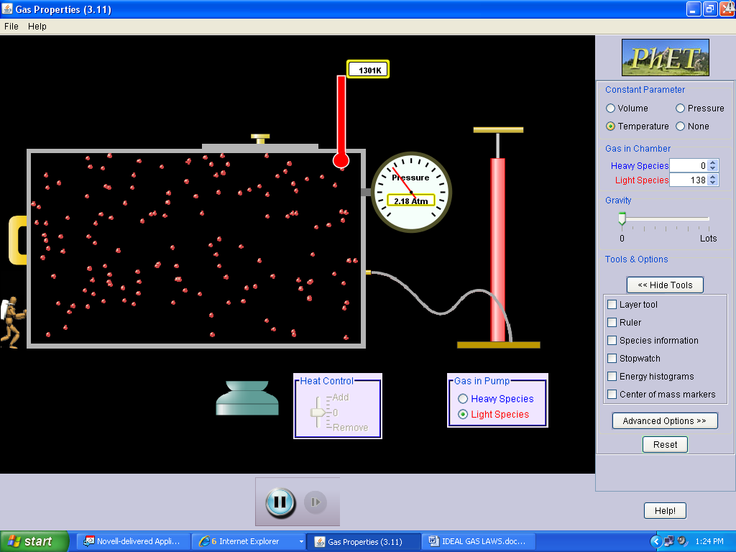 | a. Under what condition is this possible, assume that the number of molecules does not change?  b. What are the signs of Q, W and U in the process described in # a?  - Suppose that at one point, the upper cover is removed and the molecules escape from the container. What happens to the gas:  - Temperature _____  - Pressure ________  - Volume _________

