AP-C |  | Electricity & Magnetism  Induction  LR Lab | Name ____________________  Teacher __________________  Period _____

Purpose

Materials computer and internet
http://phet.colorado.edu/new/simulations/sims.php?sim=Circuit_Construction_Kit_ACDC

Background Tipler Chapter 30-8
http://hyperphysics.phy-astr.gsu.edu/hbase/electric/induct.html#c1
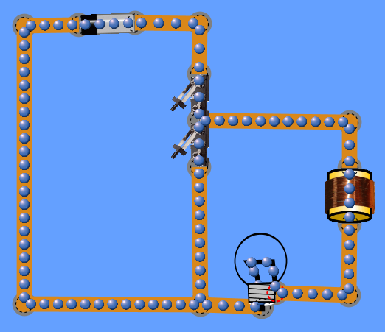

Directions
- Construct the circuit shown to the right.
- What is the unit of the quotient of inductance and resistance? Show your work below.

L =
R =
- The quotient of L and R is called the time constant. Adjust the time constant of the circuit to one second. Record the value of inductor and bulb’s resistance.
- An inductor will be fully charged/discharged in a time of 4 to 5 L/R. How long will it take your LR combination to fully charge or discharge?
time =
- Add the necessary meters and sketch the graphs of i vs t, and V_{Resistor} vs t, on the graphs below when the inductor is charging and discharging.

Inductor is Charging |  | Inductor is Discharging
Current vs. Time |  | Current vs. Time
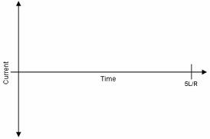
V_{Resistor} vs. Time |  | V_{Resistor} vs. Time
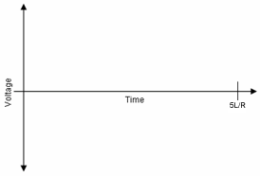
- Add the necessary meters and sketch the graphs of i vs t, and V_{Inductor} vs t, on the graphs below when the inductor is charging and discharging.

Inductor is Charging |  | Inductor is Discharging
Current vs. Time |  | Current vs. Time
V_{Inductor} vs. Time |  | V_{Inductor} vs. Time

- When is the brightness of the bulb increasing?

- When is the brightness of the bulb decreasing?

- When does the battery supply the potential to light the bulb?

- When does the inductor supply the potential to light the bulb?

- Does the direction of charge flow change through the inductor? If yes, explain when.

