An Introduction to Atmospheric Pressure

Learning Goal: Students will understand that the atmosphere has multiple layers, and one of the properties its structure is based on is pressure. Students should recognize that when gravity is applied the pressure will change at different levels and be able to predict the relative pressure at different atmospheric layers. Students will demonstrate this understanding by creating a diagram showing the factors that effect pressure in an open and closed system, and by transferring this understanding to their previous knowledge of atmospheric layers through writing.

Background Knowledge: Students background knowledge will consist of basic gas laws, kinetic theory of matter, and basic knowledge of atmospheric layers.

Prediction: What factors do you think will affect pressure?

Procedures:
- Open Gas Properties simulation in PhET http://phet.colorado.edu/simulations/sims.php?sim=Gas_Properties
- Test your prediction using the simulation. Does anything else affect pressure?
- Click on measurement tools, located on the right side of the page.
- Select layer tool.
- Explore how pressure relates to layers in open and closed systems.

Analysis:
Draw or diagram what causes pressure to vary at different layers.

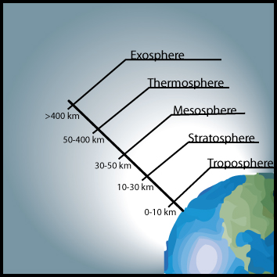

Conclusion: Applying what you have learned in the simulation, predict the patterns of pressure you would expect to find as you travel through the atmospheric layers. What else do you think would affect the pressure at each layer other than the distance from the surface of the earth.

