Physics Name _________________________________
Period ________ __________________________________
Date __________________ __________________________________
LAB: Conservation of Energy - Rollercoaster Simulation

I – Objectives: a) Analyze the physics of motion and energy involved in a rollercoaster design.

b) Apply basic formulas of Conservation of Energy and Projectile Motion to
find the distance that an object will travel when coming off a vertical drop slide.
II - Procedure:
a) Go the web site: http://phet.colorado.edu/new/simulations/index.php?cat=Top_Simulation
Choose Energy Skate Simulation and press Run Now button.
b) Modify the track configuration and place the skater at the top of the track as shown on the picture below.
c) Put a check mark on the Potential Energy Reference box and position the GPE = 0 Reference Line at the bottom of the slide. At that height level, we assume gravitational positional energy to be zero.
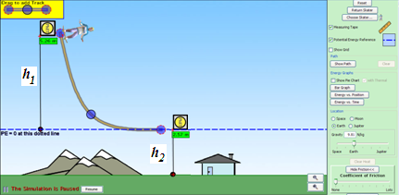
d) Put a check mark on the Measuring Tape box and measure the height of the ramp from the highest point to the GPE = 0 Reference Line. This is the h₁ height measurement.

e) Position the measuring tape as shown on the picture and measure the height of the bottom of the slide in relation to the ground. This is the h₂ height measurement.
f) Calculate the speed v₂ of the skater when he comes off of the bottom of the slide.
g) Calculate the distance d that the skater will travel when he hits the ground.
h) Position the measuring tape on the ground aligned with the bottom of the slide and open it to a length equal to the expected distance d.
i) Run the simulation and verify the accuracy of your measurements and calculations.

III – Formulas
a) Speed at the bottom of the ramp:
Energy Conservation Law: GPE₁ + KE₁ = GPE₂ + KE₂ (1)
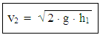
Since V₁ = 0 ➔ KE₁ = 0 and, since GPE₂ = 0 at the bottom of the slide, then equation (1) becomes
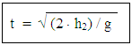
➔ GPE₁ + 0 = 0 + KE₂ ➔ GPE₁ = KE₂ ➔ m⋅g⋅h₁ = ½ m⋅(v₂)² ➔
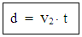
b) Time of skater’s free fall motion: h₂ = ½ g⋅t² ➔
c) Skater’s Travel Distance:

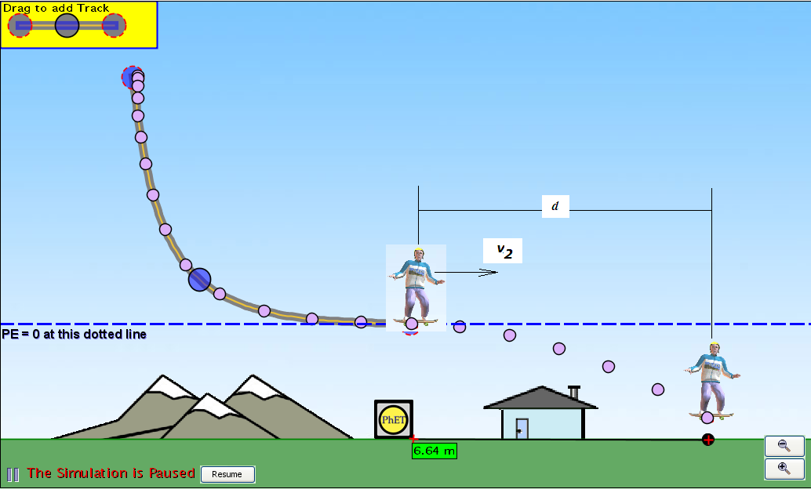

IV – Data Table:
Height h₁ (m) | V₂ (m/s) | Height h₂ (m) | Free Fall Time t (s) | Distance d (m)

