Physics PhET Lab:
A model of a planetary system

NAME ________________________

Student Learning Objectives:
- Understand Kepler’s Laws of orbital motion.
- Discover how does the distance and planet’s tangential speed affect the shape of the orbit.
- Measure the change in orbital period as distance is increased.
- Apply concepts relating to Kepler’s Laws to speculate conditions that lead to a stable planet environment for evolution of life.

Lab simulation time: 40 minutes

This is a "virtual lab". We will do an experiment using software which can be found at the PhET simulations page: http:phet.colorado.edu
Find the sim "My Solar System” and run it. You should see this:

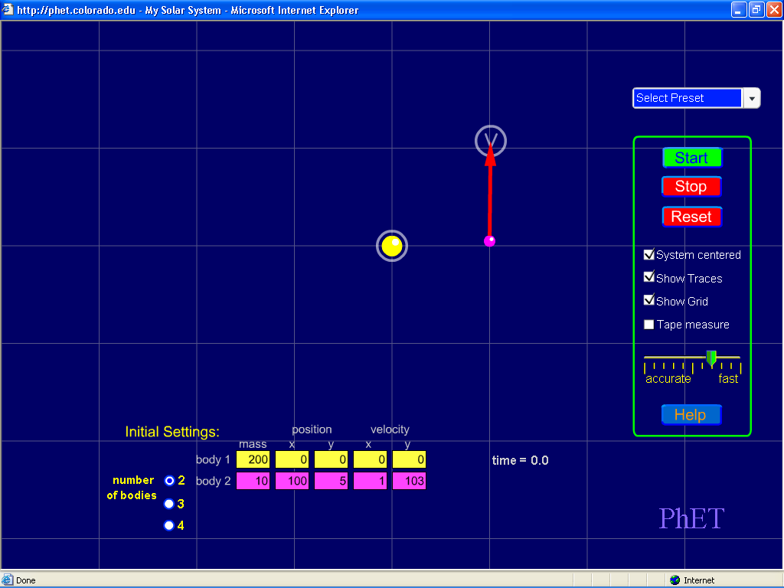

0) Play with this simulation and “mouse” around with it.. Try to figure out what all the controls do.

1) Using Select Preset, select “Sun and Planet”. Then select, System centered, Show Traces, and Show Grid. Describe the shape of the orbit. How does the distance and planet tangential speed affect the shape of the orbit?
2) Move the planet outward, and observe (and record) the orbit period. Make a graph of distance (from the star) vs. period of orbit. (Use the graph paper on next page).
3) What happens to the period as the star-planet increases? Why do you think there is a relationship?
4) Using Select Preset, select “Ellipses”. Run the simulation. Record your observation of planet orbital speed as a function of distance from the star. Come up with a quantitative and qualitative explanation for this behavior.

5) Astronomers believe that terrestrial planets in binary star system could not support advanced life. (hint: Dole (1964) estimated that the average amount of energy received by a planet not could vary by more than 10 % without affecting its habitability). Create a computer simulation that tests this hypothesis. Carefully describe the initial conditions of the simulation, your observations, and conclusions that support or refute this hypothesis.

