NAME : Gallo

- Wave aspects: Describe the changes to the wave pulse when you the 4 controls:
Amplitude controls the height of pulse: decrease it makes smaller pulses
Pulse width controls the width of pulse: decreasing it makes pulses narrower
Damping controls the friction: increasing it causes amplitude to decay to zero quicker, setting it to zero allows amplitude to remain constant forever.
Tension controls the velocity: decreasing it makes pulses go slower

- What happens to a single pulse when it reflects from the 3 different ends:
Stiff end makes it flip. Loose end – no flip. No end has no reflection at all.

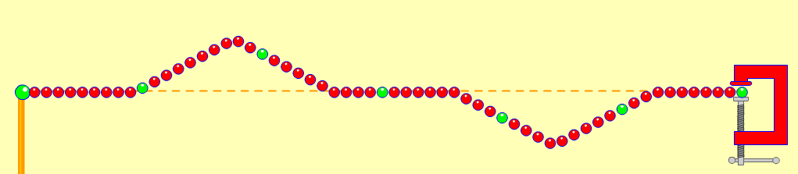
- Colliding pulses: What happens when two opposite pulses collide (as in diagram)?
Pulses go through each other. When superimposed they cancel out to zero!

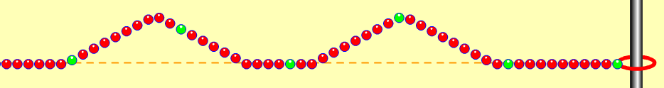
- What happens when two pulses on the same side collide?
Pulses go through each other. When superimposed they add up to double amplitude!

- Wave speed:
I measured 3.22 seconds for pulse to travel down and back, 2 meters. So v = 2m/3.22s = 0.62 m/s. The only thing that affects wave speed is the tension—lower tension makes the wave slower. Maybe damping slows it down some too (I measured 3.69s to go down and back with damping up to 27 instead of zero.)

- Standing Waves: Describe what happens to the amplitude. How is this an example of Resonance? What happens if the driving frequency is slightly off?
Amplitude grows because of resonance; the frequency of the driver matches a natural frequency of the spring cuasing it to resonate and amplitude to grow. Amplitude never grows as high with f slightly off because it’s not quite the resonant frequency of the spring.

- Where is the wave energy when it’s flat?
It’s all kinetic energy when string is flat. Even though no wave shape is apparent, each piece is moving through the zero line. When amplitude is high, nodes and anti-nodes are most visible, a lot of energy is potential—stored in the stretch of the spring.

- The initial frequency display is 50 units. Is this 50 Hertz? How can you tell? Use the timer to time 10 complete vibrations and then calculate the frequency in Hz.
50 hertz would mean 50 vibrations per second – too fast to see. It’s obviously not vibrating this fast. I measured 5.55 seconds for 10 vibrations. So f = 1.8 Hz (10/5.55).

- How many whole wavelengths are there? Compute the wavelength in meters.
3 whole wavelengths (6 standing wave segments). So 1 wavelength = 0.33m.

- Compute the velocity.
V = fλ = (1.8Hz)(0.33m) = 0.59 m/s. This is pretty close to step 8 result (0.62 m/s). Should be = since the tension is the same for both.

- Harmonics: If this were a string instrument, which harmonic is shown?
This is the 6th Harmonic,since there are 6 standing wave segments. In this series, the harmonics go up in half wavelengths.
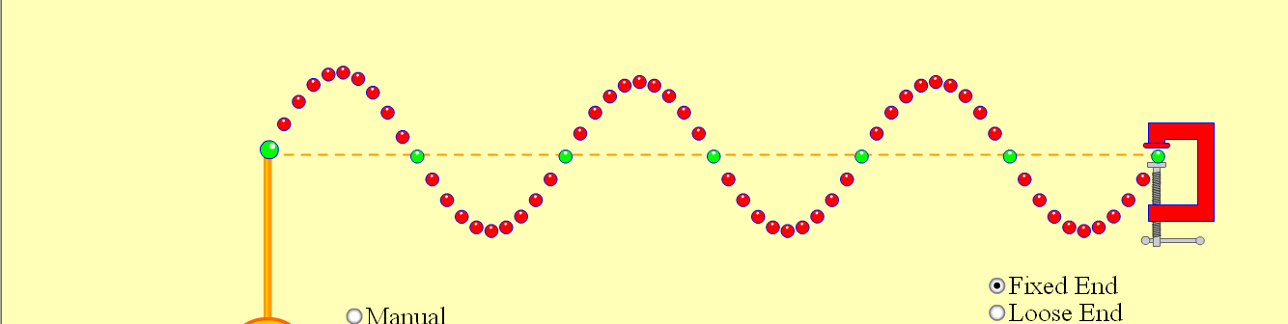

- Find the frequency setting (not in Herz) that produces the first harmonic (as drawn in Friday’s notes.) Then find it for the 2nd and 3rd harmonic. What is the pattern here?
f1 = 8 (50/6), f2 = 16, f3 = 25
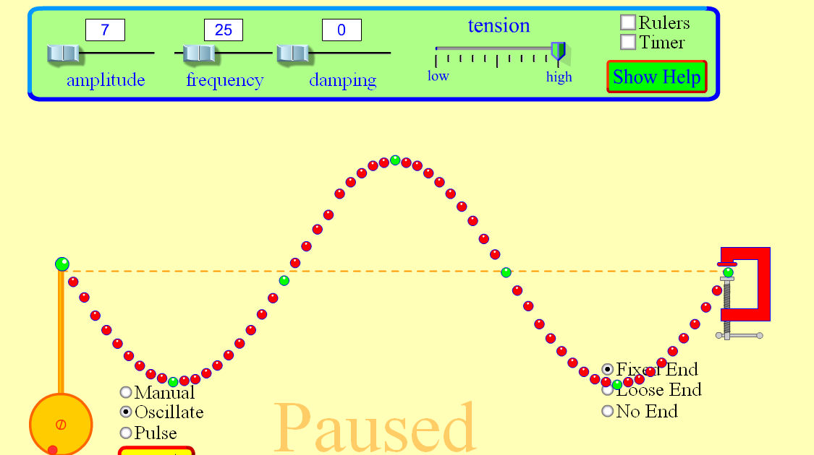
- Now set the frequency to 12 and select loose end, then click on reset. Wait a while until you can identify the standing wave pattern. To which Harmonic series does this belong? Which harmonic is it?
This is the 2nd Harmonic of the closed pipe series:
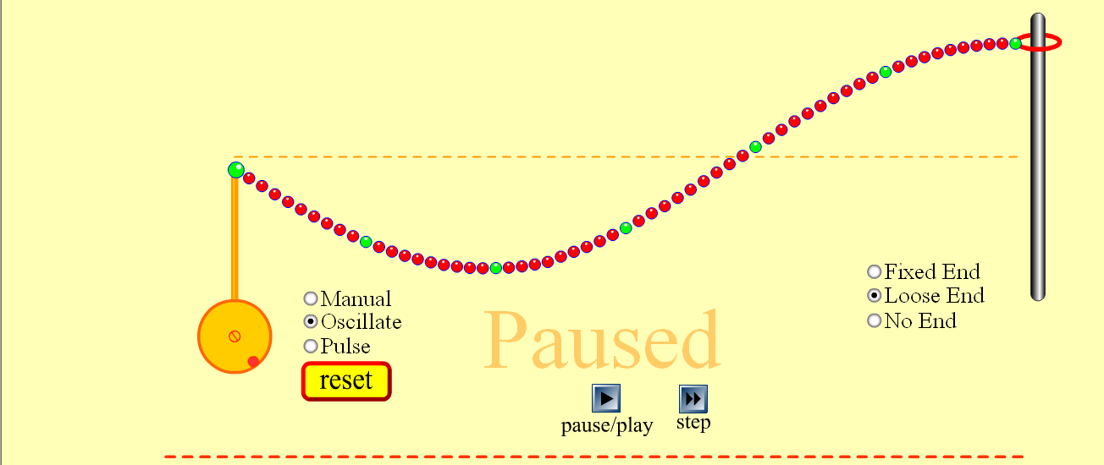
- Now find the frequency setting needed to produce the next 2 harmonics in this series. Name them and the frequency setting you used. What is the pattern here?
3rd H at f = 20, and 4th H at f = 28. This harmonic series goes by odd number quarter wavelengths: ¼, ¾, 5/4, etc. So if setting f at 12 gives the 2nd Harmonic (3/4 λ) then the 1st Harmonic should be at f = 4 (12/3). Therefore, the 3rd Harmonic should be 5 of these, f3 = 20 (5x4), and the 4th Harmonic, 7 of these, f4 = 28 (7x4).
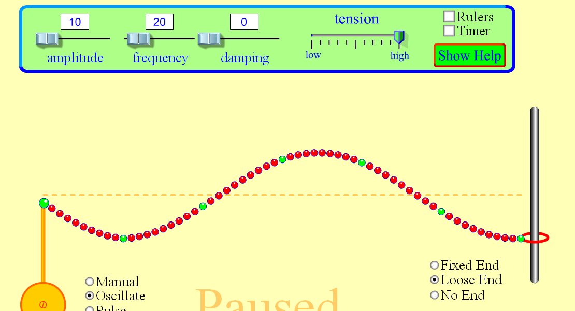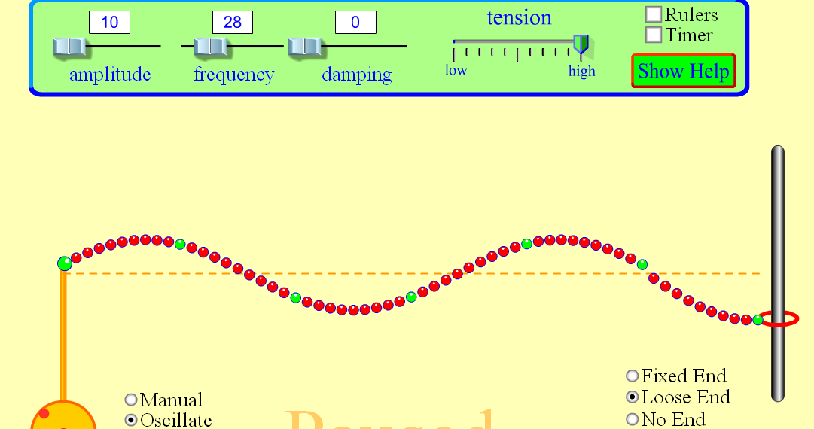
(f3) (f4)

- Try making standing waves with the No end setting. Explain your observations.
No standing waves are possible with this setting because there are no reflections!

