NAME :

- Type your name at the top of this document and then Save this file on your H: drive or on a flash drive so you can access it again if you don’t finish today.
- Minimize this window and go back to your Edline page and click on the Link named “Cool Physics Simulations.” If that doesn’t work type in this web address: http://www.colorado.edu/physics/phet/web-pages/index.html
- Click on Play with sims, then find Wave on a string, click on it and then select Run now. You should now see a virtual string wave lab. Follow the instructions below, typing in your answers to any questions directly into this word document. Print it out and turn it in when you are finished. (Due Wednesday 2/6)
- Wave aspects: Select Pulse mode and click on pulse. Experiment with the various controls. Describe the changes to the wave pulse when you vary each of the 4 controls: amplitude, pulse width, damping, and tension.
[Type your response here]

- Using pulse mode, set the tension to high and lower the damping to 1. What happens to a single pulse when it reflects from the 3 different ends: stiff end, loose end, no end.
[Type your response here]

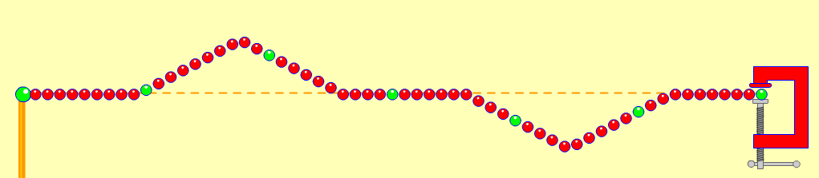
- Colliding pulses: Set the damping to zero. Using a stiff end, send one pulse then another when the first one starts to reflect. What happens when two opposite pulses collide (as in diagram)? Try it several times. You can use the reset button to clear it. Use the pause and step buttons to help you see it in slow motion. Especially note what happens when the 2 pulses are exactly superimposed.
[Type your response here]

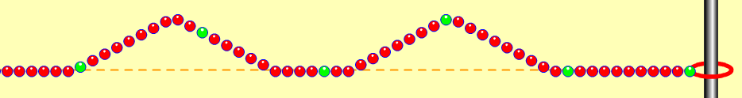
- Now repeat the above collision experiment using a loose end. What happens when two pulses on the same side collide?
[Type your response here]

- Wave speed: Set tension on high and damping zero. Now click on the timer and ruler and determine the velocity of a single pulse. Experiment and see which of the 4 wave controls affects the wave speed. How (increase or decrease?)
[Type your response here]

- Standing Waves: Set the amplitude down to 5, and the damping to zero, tension high, fixed end. Select the oscillate mode. Watch the standing waves for a few minutes. Describe what happens to the amplitude. How is this an example of Resonance? What happens if the driving frequency is slightly off? (Try setting f = 49, and f = 51).
[Type your response here]
- Use the pause and step buttons to see what the standing wave looks like at various points. Where is the wave energy when it’s flat?
[Type your response here]

- The initial frequency display is 50 units. Is this 50 Hertz? How can you tell? Use the timer to time 10 complete vibrations and then calculate the frequency in Hz.
[Type your response here]

- How many whole wavelengths are there? Compute the wavelength in meters.
[Type your response here]

- Compute the velocity using the wave equation: v = fλ. Why should your answer be similar to your result in step 8?
[Type your response here]

- Harmonics: If this were a string instrument, which harmonic is shown? (See Smart Board Notes in the Lesson Notes folder on Edline—especially if you missed class on Friday.)
[Type your response here]

- Find the frequency setting (not in Herz) that produces the first harmonic (as drawn in Friday’s notes.) Then find it for the 2nd and 3rd harmonic. What is the pattern here?
[Type your response here]

- Now set the frequency to 12 and select loose end, then click on reset. Wait a while until you can identify the standing wave pattern. To which Harmonic series does this belong? Which harmonic is it?
[Type your response here]

- Now find the frequency setting needed to produce the next 2 harmonics in this series. Name them and the frequency setting you used. What is the pattern here?
[Type your response here]

- Try making standing waves with the No end setting. Explain your observations.
[Type your response here]

When finished, review your answers then print it out and turn it in. (Due Thursday 2/7)

Suggestion: If you finish early, try out some of the other wave related simulations on this web site.

