Lab 4. DC Circuits II

INTRODUCTION:
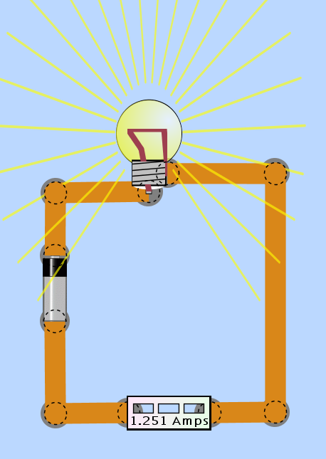
This week we will continue with DC circuits, but now with an emphasis on current rather than voltage. Of course, in order to fully understand any circuit, you need to take into account both voltage and current. Additionally, we will be using a computer simulation called the Circuit Construction Kit (CCK) instead of real wires, bulbs, and resistors. The goals of this lab are to complete our understanding of how voltage, current, and resistance relate to each other in circuits, and to learn how to use an ammeter to measure current directly.

PRECAUTIONS & NOTES:
To measure how much current is flowing through a circuit, the current needs to flow through the ammeter. Recall that when we measured voltage differences, we attached the voltmeter in parallel with whatever we were measuring. To measure current, the ammeter needs to be placed in series with the element (resistor, bulb, battery) that we are measuring (see figure at right).

Ammeter configured to measure current.

PART I: MEASURING CURRENT DIRECTLY WITH THE AMMETER
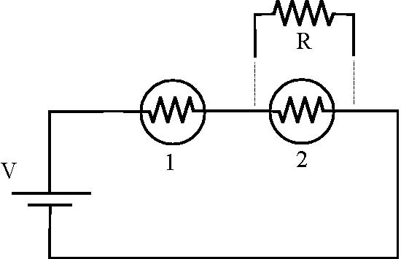
Drag and drop one 2 Ω resistor into the work area (if you right click on a resistor, you can change its resistance) and two light bulbs into your work area.
Construct the circuit shown on the right, consisting of two light bulbs (with the same resistance) in series with a battery. (The resistor R will be added later). Increase the voltage across the battery to 20 V (right click on the battery to change its voltage).

Predict what will happen to the current flowing from the battery when you place a (R = 2 Ω) resistor in parallel with bulb #2 as shown in the schematic. Explain your reasoning.

Measure the voltage difference across the battery, then put the ammeter in the circuit so that you can measure the current flowing from the battery. Measure and record the battery voltage difference and current here.

Add in the R = 2 Ω resistor, and describe what happens and why. Were your predictions correct?

PART II: COMPUTING THE RESISTANCE OF A LIGHT BULB
Build a circuit consisting of a battery in series with a 15 Ω resistor and one light bulb (see diagram below).
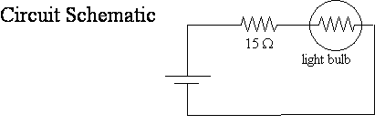
Set the voltage difference across the battery to 30 V. Using the voltmeter with needle probes, measure the voltage difference V_{BATT} across the battery, the voltage difference V_{R} across the 15 Ω resistor, and the voltage difference V_{BULB} across the light bulb. Using the known resistance of the resistor, compute the current I_{R} flowing though the resistor.

Now set up the ammeter to directly measure the current I_{R} flowing though the resistor. Does this value match the calculated I_{R} from the previous step?

How is the current flowing though the light bulb (I_{B}) related to the current flowing through the resistor (I_{R})? What is the relationship between the three measured voltage differences V_{R}, V_{BULB}, and V_{BATT}?

From these measurements, compute R_{BULB}.

Using the measurements and calculations from this section, how much power is dissipated in the 15 Ω resistor? How much power is dissipated in the light bulb?

PART III: 2 BULBS IN SERIES
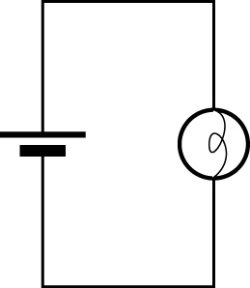
Construct the circuit shown at right, containing a single light bulb. Set the battery voltage to 20 V. Using the voltmeter and the needle probes, measure the voltage difference across the light bulb. Then use the ammeter to measure the current flowing out of the battery. Record your results.

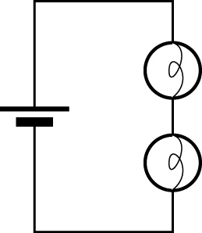
Predict what will happen if a second bulb is added in series with the first bulb, as shown at right. Will the bulb brightness change? Will the current flowing through the first bulb change? Will the current coming out of the battery change? Will the voltage difference across the first bulb change? How will the power change (for each bulb and in total) if at all? Clearly explain your reasoning.

Add a second bulb to the circuit in series with the first bulb (as shown in the previous diagram). How does the brightness compare to the single-bulb case?

Measure the voltage difference across each bulb and record the result. Using the ammeter, measure the current coming from the battery and record the result. Do these results match your predictions? If not, explain the measurement.

PART IV: 2 BULBS IN PARALLEL
Construct the circuit shown at right, containing a single light bulb. Set the battery voltage to 10 V. Using the voltmeter and the needle probes, measure the voltage difference across the light bulb. Then use the ammeter to measure the current flowing out of the battery. Record your results.

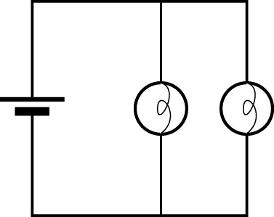
Predict what will happen if a second bulb is added in parallel with the first bulb, as shown at right. Will the bulb brightness change? Will the current flowing through the first bulb change? Will the current coming out of the battery change? Will the voltage difference across the first bulb change? How will the power change (for each bulb and in total) if at all? Clearly explain your reasoning.

Add a second bulb to the circuit in parallel with the first bulb (as shown in the previous diagram). How does the brightness compare to the single-bulb case?

Measure the current flowing out of the battery, and measure the current flowing through each of the bulbs individually. Record your results here. How are these three measurements related?

PART V: FOUR BULB CIRCUIT
Do not build the following circuit. First, rank the brightness of bulbs A, B, C, and D in order from brightest to dimmest BEFORE the break in the circuit is made (circuit a).

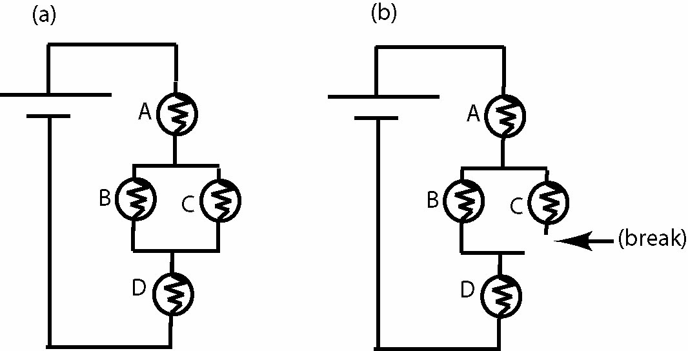

What happens to the brightness of each bulb (A, B, C, and D) AFTER the break is made? Does each bulb get brighter, dimmer, or stay the same? Explain your reasoning.

Build the circuit now and test your prediction. Set the battery voltage to 30 V. Add a switch where the “break” appears. Were your predictions correct?

PRELAB QUESTIONS: (to be turned in upon arriving at lab)

1. Read the lab thoroughly.
2. Familiarize yourself with circuits and circuit diagrams in your book (chapter 19, sections 1-3).
3. Suppose the resistance of your body between your right and left hands is 500 kΩ. What would be the current flowing through your body if you touched the plus and minus terminals of the battery used in this lab, with the voltage turned all the way up? The threshold of sensation for electric current through your body is about 300 μA. Would you feel the current?
4. Make a sketch to show how you would connect two light bulbs in parallel to the battery, while using the ammeter to measure the current flowing out of the battery.
5. Rank the brightness of each bulb (A, B, C, D, and E) from brightest to dimmest.

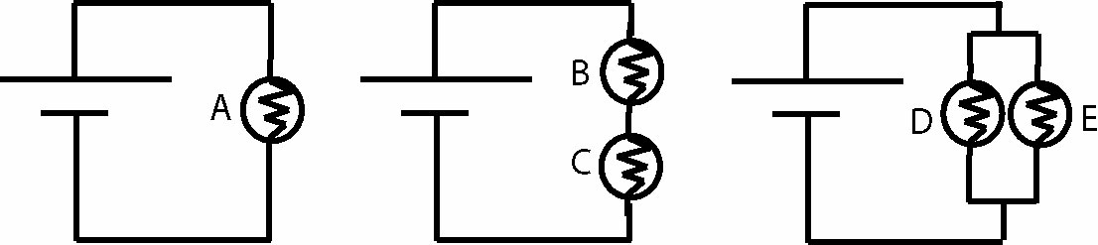
POTENTIAL EXAM QUESTIONS:

1. Which of the following statements is/are true about the following circuits? Assume all batteries and all bulbs are identical.
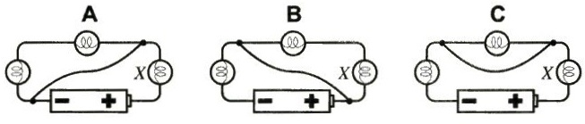
a) Bulb A does not turn on, because the voltage difference across it is zero.
b) Bulb B does not turn on, because the voltage difference across it is zero.
c) Bulb C does not turn on, because the current flowing through it is zero.
d) Answers (a) and (b) are both true.
e) Answers (a), (b), and (c) are all true.

2. What is the correct order for the total power dissipated in the following circuits, from least to greatest? Assume all bulbs and all batteries are identical. Ignore any internal resistance of the batteries.
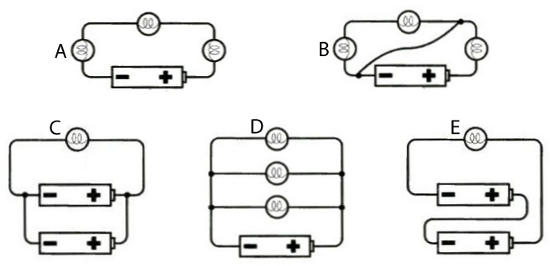
a) A < B = C < D < E
b) D < C < B = E < A
c) D < B < E < A < C
d) A = B < D < C < E
e) B < A < C = D < E

