Learning Goals: Students will be able to explain
- How a converging lens makes images.
- How changing the lens effects where the image appears and how it looks.

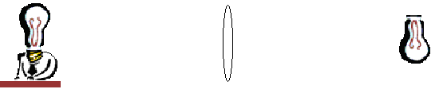
1. When you did the Lens Lab, you were able to see an image of a light bulb on your note card as in Figure 1.

Figure 1

How do you think the lens changes the light from the bulb to make an image? Why do you think the image was upside down?
- Discuss your ideas with your partner and then make drawings of your ideas.
- Use Geometric Optics to test your ideas. Talk about changes in your thinking.

3. Write an illustrated summary for this learning goal: “Explain how a real image is formed by a converging lens using ray diagrams.” Make sure to include why the image is upside down and varies in size and location.

4. If you wanted to make your own lenses for a telescope, what features of a lens do you think would affect the images that you can see?
- Use the simulation to test your ideas. Make a table to summarize how each variable affects how an image looks.
- 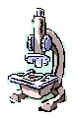Describe the characteristics that would be best a telescope lens. Explain why your choices would work well.
- What would you choose if you were going to make a microscope? Why?

5. Use your magnifying lens to look at this paper.
- Investigate how to make words appear as large as possible.
- Discuss with your partner how you think the image is formed.

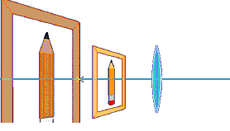6. Use Geometric Optics with Virtual Image turned on; keep the object on the left side. Imagine that you are on the right looking into the lens like the picture below.

- Type a letter, on a separate sheet, to your parents explaining how a magnifying lens works include how size and location of what you see changes. Illustrate your letter showing how the light rays change to make you see an image

